**Team Name**: We Can Do It

**Date of Submission:** 10/17/2021

**Meeting Date & Time:** 10/14/2021 @ 6:00PM

**Meeting Location:** Zoom

**Meeting Duration:** 1 hour and 8 minutes

| **Team Members** | **X = Present** | **Notes** |
| --- | --- | --- |
| Dhari Alenezi | X |  |
| Abdulrahman Alharbi | X |  |
| Elina Do | X |  |
| Andrew Nguyen | X |  |

**Progress:**

**Team accomplishments for the week:**

This week we had our meeting with the WPD in the Law Enforcement Training Centre. We showed them the app with its current functionality and presented it to them. We loaded the application into an iPhone so the WPD could test it as we presented about its different functions step by step on the emulator. We showed them how to log in to the app and add cases to the app. We got feedback from the WPD about the app and their likes and dislikes. They wanted to have a case ID section added to the cases so they can identify cases easily by searching for the case ID.

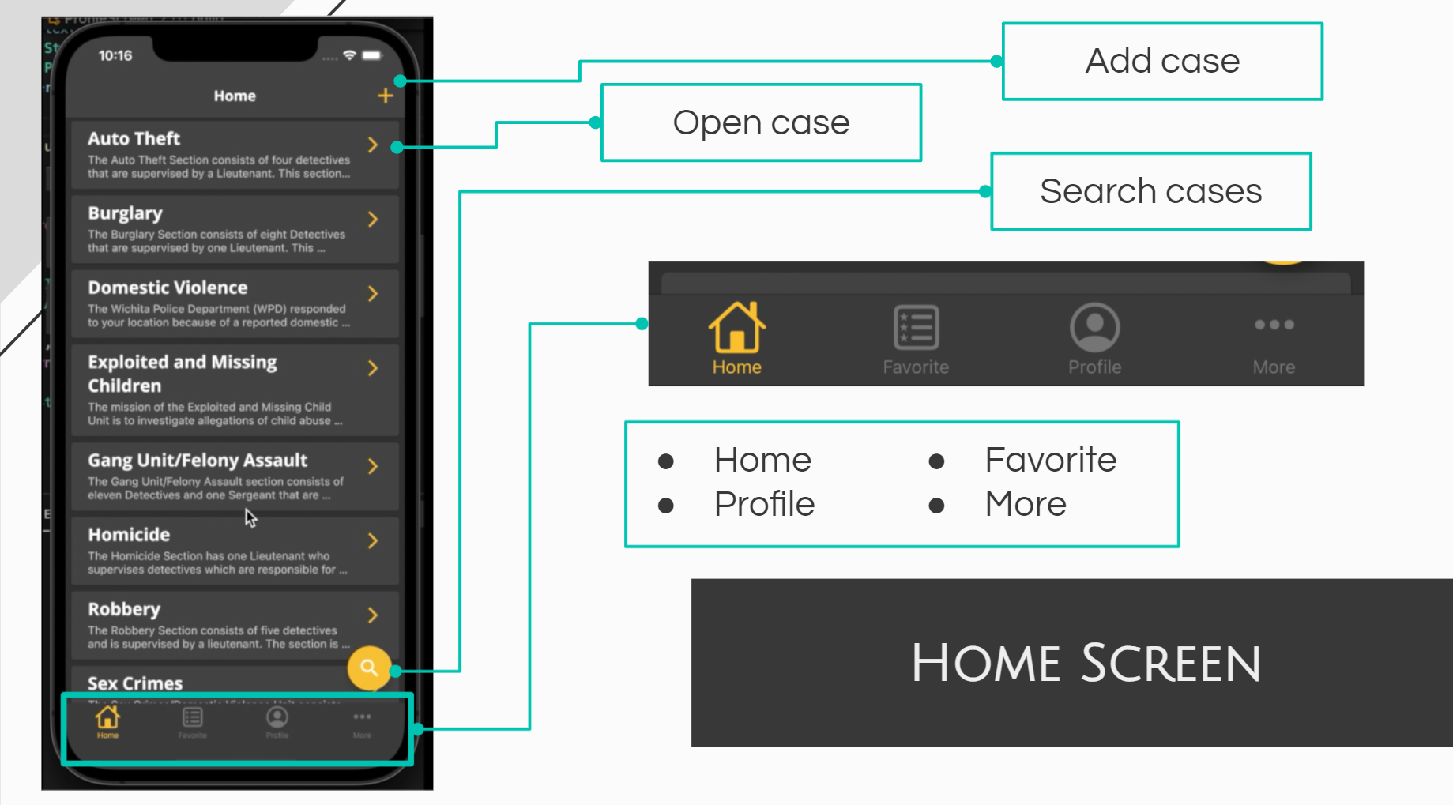

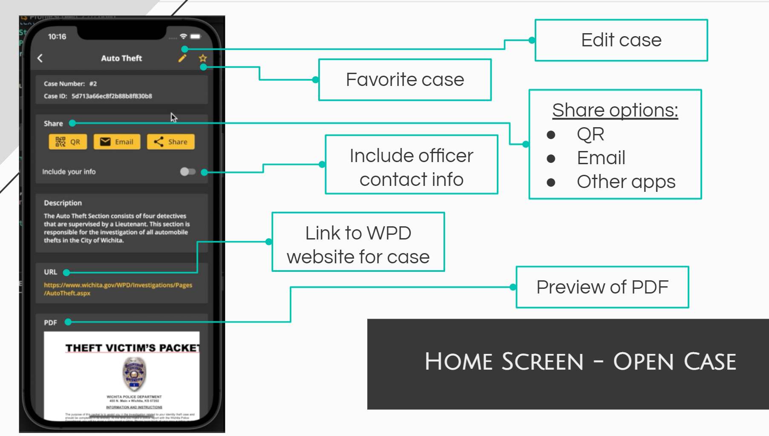

**Individual contributions:**

**Dhari Alenezi:** This week I released a test app, and I was testing it on the police phone, and I found some bugs while I was testing it, so I fixed these bugs on the backend and mobile sides. Also, I developed the upload pdf feature.

**Abdulrahman Alharbi:** I have been reading about the user guide manual and how to create an easy user guide manual. Also, I have looked in examples for user guide manuals created for mobile applications. To help with creating a user guide manual for our App

**Elina Do:** I created the presentation for our meeting with the WPD and added more to the sample cases .json file. I have also been communicating with our TPR teams to set up a time and discuss.

**Andrew Nguyen:** I have been making minor updates on the website that presents the case information and useful information. Working on the responsiveness of it to make sure it's compatible with mobile devices as well as desktop. Started working on a search page for users to enter in the unique ID to look up the case information and details.

**Project Tracking:**

| **Team Member** | **Assignment** | **Due Date** | **% Complete** |
| --- | --- | --- | --- |
| Dhari Alenezi | Developing category screen | 10/22/2021 | 30% |
| Abdulrahman Alharbi | Working on building user guide manual | 11/18/2021 | 5% |
| Elina Do | Complete first draft of base code for database in MongoDB | 09/17/2021 | 50% |
| Andrew Nguyen | Create static web prototype for WPD to test and give feedback on | 09/19/2021 | 100% |
| Andrew Nguyen | Link web app with back end to display information | 10/06/2021 | 100% |
| Andrew Nguyen | Minor Improvement for dynamic page of web app to present the data | 10/22/2021 | 80% |
| Andrew Nguyen | Add in a search function to search up the case detail with the unique ID | 10/30/2021 | 20% |

**Plan:**

| **Assignment** | **Due Date** |
| --- | --- |
| Developing category screen | 10/22/2021 |
| Support web application | 10/27/2021 |
| Try & test NFC technology (Near-field communication) | 10/30/2021 |
| Developing the cache feature for the mobile app | 10/31/2021 |
| Testing both the frontend & backend sides | 11/7/2021 |
| Web App final review | 11/14/2021 |
| Web App finalized and ready for presentation | 11/28/2021 |
|  |  |
|  |  |
|  |  |
|  |  |
|  |  |

**Issues:**

Include the schedule for the next meeting:

Meeting Date & Time: 10/23/2021 @ 6:00PM

Meeting Location: **Zoom**